Why Outdoor Education and Mindfulness is Vital to Maine Students

Ian Ramsey-Director of Kauffmann Program- North Yarmouth Academy, board member of https://physiologyfirst.org/
iramsey@nya.org
Ianramsey.net
@ian.ramsey
Ianramsey.net/resources

What if the anxiety, depression, obesity that we commonly see in students is not a disorder?
What if it’s an appropriate response to a certain level of stimulus and physiological disruption?

Are students benefitting from:
Sitting most of the day under florescent lights?
Looking at screens during most waking hours?
Eating food that spikes their blood sugar?

Maybe we need to change the system so that their biology is working for them, not against them.

Nature-based and adventure-based education, in conjunction with mindfulness/breath training offers students tools to learn to downregulate their autonomic nervous system and mange anxiety, to manage their personal state, and to have more agency in their lives. It can also help them to live a life that is more movement-rich and more connected to where they live, with greater empathy for the environment.

The Problems
- Maine has the highest rate in the nation of children diagnosed with anxiety (16%), and the third highest rate of kids diagnosed with depression.
- the suicide rate among Maine teens is also on the rise, and above the national average.
- Despite the fact that Maine children have the highest rate of access to mental health counseling
- 1 in 6 american adults takes a psychiatric drug
- In US 40 million adults and 4.4 million kids are diagnosed with generalized anxiety disorder and prescribed medications with no clear path off of them
- According to the NIH, nearly 1 in 3 adolescents age 13-18 will experience an anxiety disorder, has been steadily increasing
- 57% of today’s children ages 2–18 will be obese by the time they are 35. As of 2018, 18.5 percent of children were obese. That means that 39 percent of today’s children will join the ranks of the obese.
- With increased screen time, students are reporting what science is calling Digital Concussions: long-term screen time results in chronically dilated pupils (when we look at things up close or are stressed, pupils dilate), which physiologically results in increased vigilance and stress as the pupils get locked in that mode. Headaches and dizziness result from eye and face muscle strain
- Due to more sitting and a less movement-rich life, students are getting injured more often. For instance there is a 400% increase in torn ACLs in female athletes in the last 15 years
- Climate Change and related problems (extinction, refugees, habitat loss, pollution, energy use, etc.) will probably be the biggest issue this generation of kids will deal with
Causes
- Kids spend 85% of their waking hours sitting: commuting, sitting in class, doing homework, etc.
- Biomechanical causes (postural deviations, breathing dysfunction) of high arousal result from sitting all day
- Students develop dopamine resistance and chronic stress from constant digital/social media stimulation
- Looking at screens consistently during the day, and particularly between 11PM-4AM activates a part of the brain called the habenula, resulting in prodepressive symptoms, deficits in memory and learning, and a greater likelihood to be obese
- Spending most time indoors with consistent exposure to blue light screens disrupts metabolism, circadian rhythms, sleep, mood, and pro-social behaviors
- It is well documented that undirected exploration of space, particularly of a kid’s own neighborhood, is an important part of childhood development and gives them the chance to test themselves socially, mentally and physically in small real-life situations and prepare them to be independent adults.
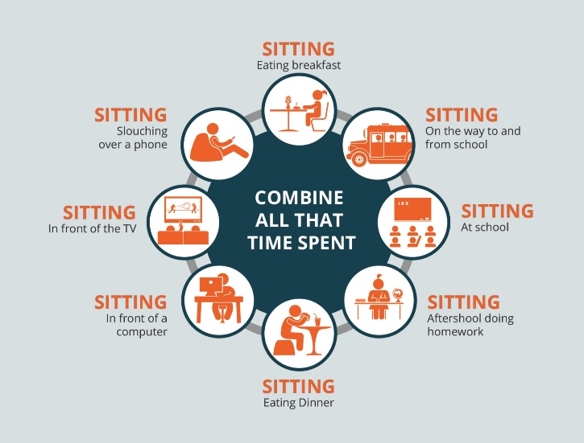

Solutions
- Outdoor-based and Adventure Education
  - Negative ions: reduce depression, promote antimicrobial activity, and uplevel cognitive performance
  - Being outside: lowers cortisol and stress, and enhances learning. It can reduce the symptoms of Attention Deficit Disorder, and improve focus. In a world where we’re constantly surrounded by manmade electrical signals and wifi, which have been proven to cause oxidative stress, neuropsychiatric and cellular DNA damage, and to impact the endocrine system, it’s important to get away from that kind of non-iodizing radiation.
  - Empathy for Natural World: Climate Change, learning about where they live
  - Logical place to teach students how to control their physiology/mindfulness
  - Reflection: an important part of the adaptive neuroplasticity that is often overlooked
  - Outside movement and seeing natural light lowers cortisol and results in better sleep, which helps learning (integration of working memory happens when we’re sleeping)
- Create a movement-rich environment that allows students to switch on their physiology and brain chemistry
  - Standing desks in the classroom, getting outside, consistent movement breaks
  - Helps students to move in diverse ways and develop full range-of-motion
- Mindfulness and other techniques
  - Slow controlled exhale: affects vagus nerve which control heart and heart-rate variability,, state and physiology
  - Panoramic Vision- dial out your vision to the horizon and relax (vs stressed soda straw vision)
  - Mindfulness Techniques/Box Breathing
  - Outdoor light to manage metabolism, attention, mood, body temperature : Neurons in eyes control mood and body temperature (vs chronic stress from fluorescent lights)
  - Opportunity to teach students cognitive literacy

Resources:
https://physiologyfirst.org/
Breathe to Perform
https://www.outdoor-learning.org/
Andrew Huberman-Stanford Neuroscientist:
David Berson-Brown Neuroscientist
Flow Research Collective
Flow Genome Project

